

## APPENDIX 1

**STUDENT REPORT MANAGEMENT SYSTEM**

**A PROJECT REPORT**

***Submitted by***

*SHIVAM KUMAR*

*KADULURI HARSHITH*

*NIKITA SAH*

*JETTIBOINA V K SWAMY NAIDU*

**NAME OF THE CANDIDATE(S)**

SHIVAM KUMAR (21BCS3486)

KADULURI HARSHITH (21BCS3235)

NIKITA SAH (21BCS3134)

JETTIBOINA V K SWAMY NAIDU (21BCS3376)

***in partial fulfillment for the award of the degree of***

**BACHELOR OF ENGINEEERING**

**IN**

**COMPUTER SCIENCE AND ENGINEERING**



**Chandigarh University**

APRIL & 2022

### APPENDIX 2



## BONAFIDE CERTIFICATE

Certified that this project report **“ STUDENT REPORT MANAGEMENT SYSTEM ”** is the bonafide work of “ **SHIVAM KUMAR, KADULURI HARSHITH, NIKITA SAH, JETTIBOINA V K SWAMY NAIDU ”** who carried out the project work under my/our supervision **PARVEEN KAUR**.

**SIGNATURE SIGNATURE**

**SUPERVISOR HEAD OF THE DEPARTMENT**

Submitted for the project viva-voce examination held on

##### INTERNAL EXAMINER EXTERNAL EXAMINER

## Specimen

(A typical Specimen of Cover Page & Title Page)

<Font Style Times New Roman – Bold>

# SOME PERFORMANCE ASPECTS CONSIDERATIONS OF A CLASS OF ARTIFICIAL NEURAL NETWORK

### A PROJECT REPORT

#### Submitted by

**SHIVAM KUMAR (21BCS3486)**

**KADULURI HARSHITH (21BCS3235)**

**NIKITA SAH (21BCS3134)**

**JETTIBOINA V K SWAMY NAIDU (21BCS3376)**

***in partial fulfillment for the award of the degree of***

**BACHELOR OF ENGINEERING**

**IN**

**COMPUTER SCIENCE AND ENGINEERING**



**Chandigarh University**

APRIL 2022

##### ACKNOWLEDGEMENT

I would like to express my special thanks of gratitude to my teacher **PARVEEN KAUR** who gave me the golden opportunity to do this wonderful project on the topic **STUDENT REPORT MANAGEMENT SYSTEM**, which also helped me in doing a lot of Research and I came to know about so many new things I am really thankful to them.  
Secondly i would also like to thank my group members who helped me a lot in finalizing this project within the limited time frame.

- SHIVAM KUMAR

21BCS3486

**TABLE OF CONTENTS**

1: Abstract

2: Introduction

3: Literature Review

4: List of Figures

* Interface
* Main Menu
* Result Menu
* Entry Menu

5. Reference

6. Conclusion

1. **Abstract -**

Students form a main part of any institution that concerns with. But the institutions

find it difficult to keep details of so many students of the organization just in one

stretch. It will involve a lot of pen paper work. Sometimes there will be some huge

heap of files bundled up and kept together in some corner of the office. If you want

any information regarding the particular student then it can be obtained by just

entering the roll number or the name of the student to be searched. This student

management system will make the work of storing the data in an organized way.

The student management system application will help in managing the student's

reports, results and exams will become easier with one such system. It will also help

in saving time and effort. The user interface must be user friendly and easy to

understand. The information of the particular student will be obtained in just one

mouse click.

1. **INTRODUCTION**

The project Student Report Card Management is aimed to

efficiently store and retrieve student examination reports.

This project in C++ is a simple console application built

without any graphical Interface. In this project, users can

perform typical report card related functions like adding a new

student record and displaying, modifying, editing and deleting

it. File handling has been effectively used to perform all these.

This project will teach you how to use file handling in C++,

add, read, display, search, modify and delete record from file.

The key features and the functions used for the Student

Report Card Management are:

**1. Create student report card record:** This feature

creates a new student record containing his marks. void

write_student(); function writes a record in a binary file. For

this the information to be provided are the name and roll no.

of the student, and the marks obtained by him/her in 5 subjects

– OOPs, Data Structures, Analog and Digital Electronics,

Computer Organization and Architecture and Computer

Oriented Statistical Methods.

**2. Read all students report card record:** The void

display_all(); function in this student report card management

system project in C++ has been used for this feature. It shows

the progress report of all the students added in file. This

feature displays the roll no. and name of all the students, the

marks obtained by them in 5 subjects – OOPs, Data Structures,

Analog and Digital Electronics, Computer Organization and

Architecture and Computer Oriented Statistical Methods

along with the percentage and grade of each student.

**3. Read specific student’s report card record**: This

feature is same as the one explained above, except it shows the

progress report and relevant data related to a particular

student. void display_sp(int) is used for this purpose.

**4. Display all students’ grade report:** This feature enlists

all the students’ record saved in file. The grade report is

displayed in a tabular form with roll no. and name of the

students, marks achieved in the five subjects, and the grade

and percentage obtained by them. void class_result(); is thus

used.

**5. Modify student’s report card record:** void

modify_student(int); function is used to edit the report card

record of a particular student. For this, the name and roll no.

of the student is sought. Upon successful modification, the

program displays the message “Record Updated”. If no record

of student is found in file, it displays the message “Record not

found”.

**6. Delete student record:** void delete_student(int);

function deletes the report card record of a particular student;

it first of all asks for the name and roll no. of the student whose

record is to be deleted.

**3) LITERATURE REVIEW**

How to Get the Most Out of Your Student Report Management Systems? With its rising popularity, more and more institutes are now adopting the student information report management system.

It’s no surprise that the global market size for student information systems tends to grow to USD 9.0 billion by 2023 from USD 5.0 billion in 2018.

Most schools use student information systems (SIS) as a standalone tool and use different applications for other purposes like classroom management, online courses management, and more.

However, there are many products that claim to offer all-in-one solutions.

But while deciding to implement an SIS solution, you need to be mindful of the tools and applications that you choose. Create and manage your stack of applications in a way that offers you maximum ROI.

Student Record Management Systems Features and Capabilities

Now let’s look at some of the features that a student record management system offers

1. Admission Management :

The admission management module streamlines and automates every aspect of the admission process, including filling up online forms, fee submission, batch allotment, and document submission. It helps collect students’ information quickly as well as accurately.

1. Attendance Management :

This module allows teachers to mark and view the attendance of any respective students. Using the system, they can even share the attendance status of a student with their respective parents. It also keeps track of staff members’ complete attendance records.

1. Document Management :

Document management allows you to upload/enter complete students’ details. It includes contact details, parents’ details, report cards, health details, and more. All information is safely kept.

1. Fee Management :

It helps you manage all the fee-related tasks such as accepting fees, keeping fee records, maintaining receipts, taking care of dues and refunds, and more. It also allows you to create the fees cycle of the school.

**4) LIST OF FIGURES:**

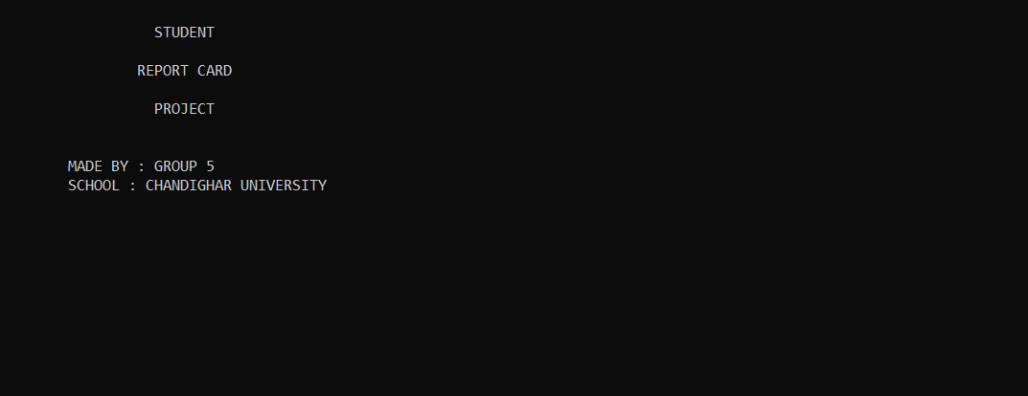

Fig 1 Interface

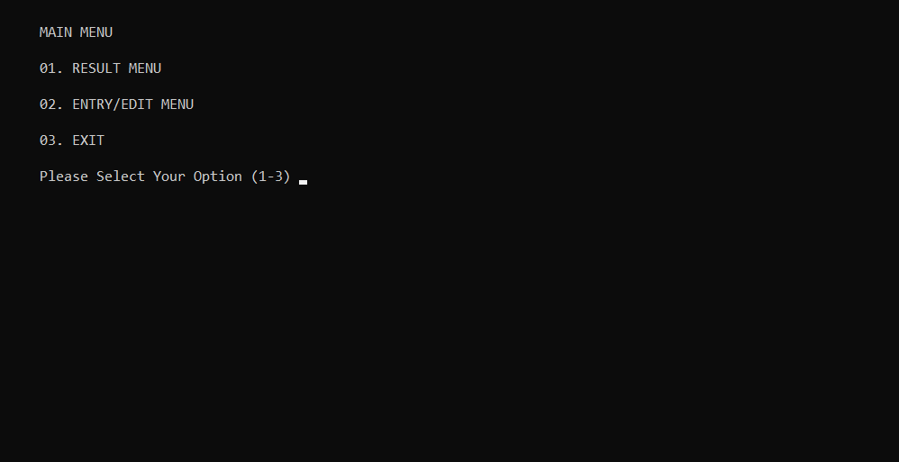

Fig 2 Main Menu

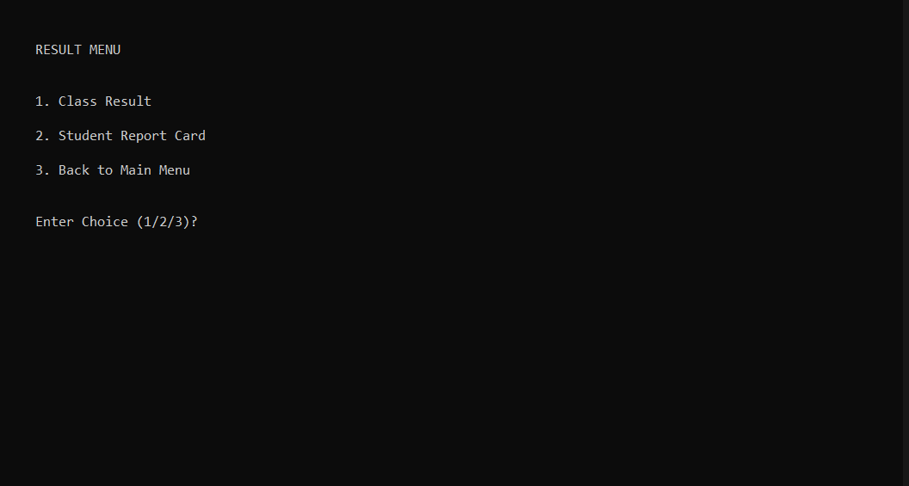

Fig 3 Result Menu

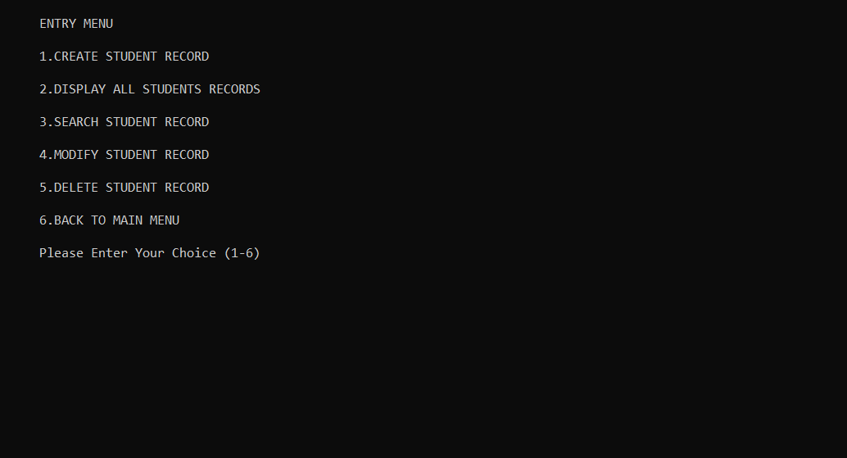

Fig 4 Entry Menu

**5) REFERENCES :**

[1] https://www.geeksforgeeks.org/file-handling-c

classes/?ref=lbp

[2] https://www.geeksforgeeks.org/header-files-in-c-cpp-and-its

uses/#:~:text=In%20C%2B%2B%20program%20has,just%20

need%20to%20import%20them.

**6) CONCLUSION :**

This report contains the Student Report Card Management

project made using CPP by Group #5, 21PH401(B) submitting for

our Object-Oriented Programming using C++ mini project in

the academic year 2021-22.